**P&ID/Plant 3D project – automation installation**

## **Vălcăuan Adina – Diana 30311**

# Inspiration

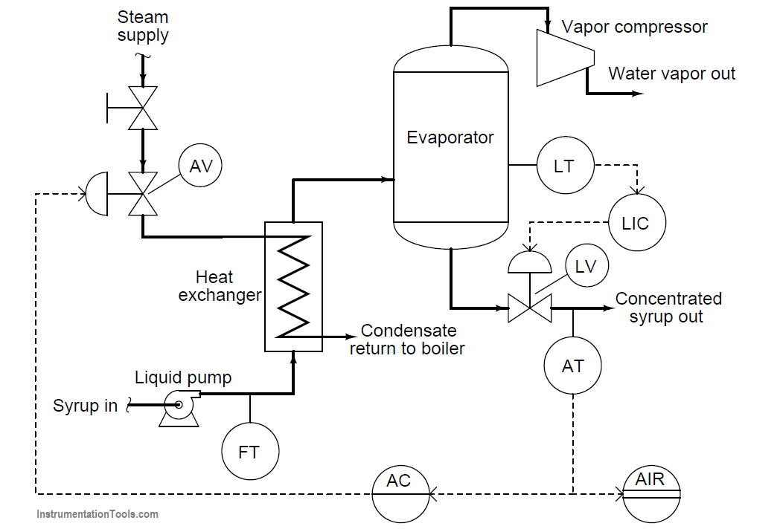

# Description

This automation installation is related to the steam heat exchanger level with marple syrup.

In this process, maple syrup is heated as it passes through a steam heat exchanger, then enters an evaporator where the water boils off. Searching on different websites, I found out that the purpose of this is to raise the sugar concentration of the syrup, making it suitable for use as a food topping.

LT, LIC, and LV known as level control systems maintains constant syrup level inside the evaporator, while an analytical [control system](https://instrumentationtools.com/overview-of-industrial-control-systems/), such as AT, AIR, AC, and AV, monitors the sugar concentration of the syrup and adjusts steam flow to the heat exchanger accordingly.

# AutoCAD drawing

